**VPC INTERNET CONNECTIVITY**

STEP-1: VPC Creation.

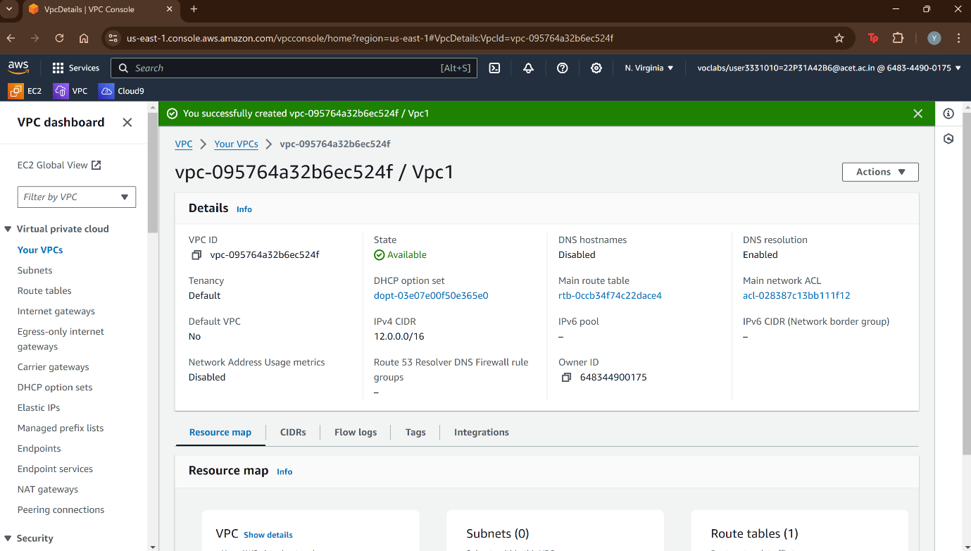

STEP-2: Create an Internet gateway.

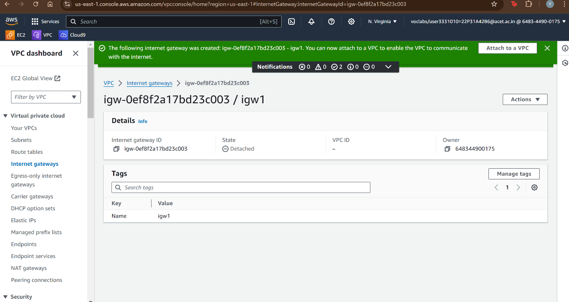

STEP-3: Attach internet gateway to VPC.

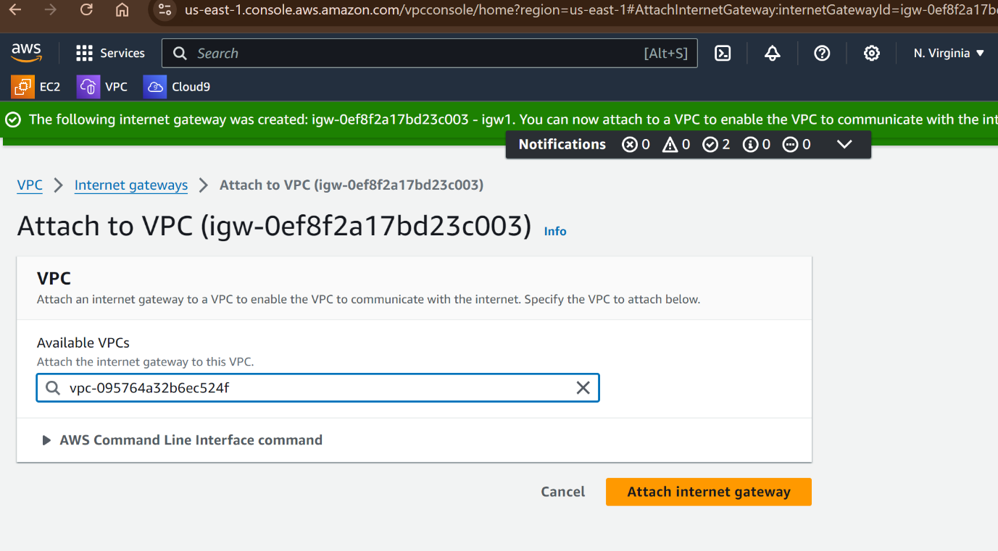

STEP-4: Create Subnets i.e. Public subnet and Private Subnet.

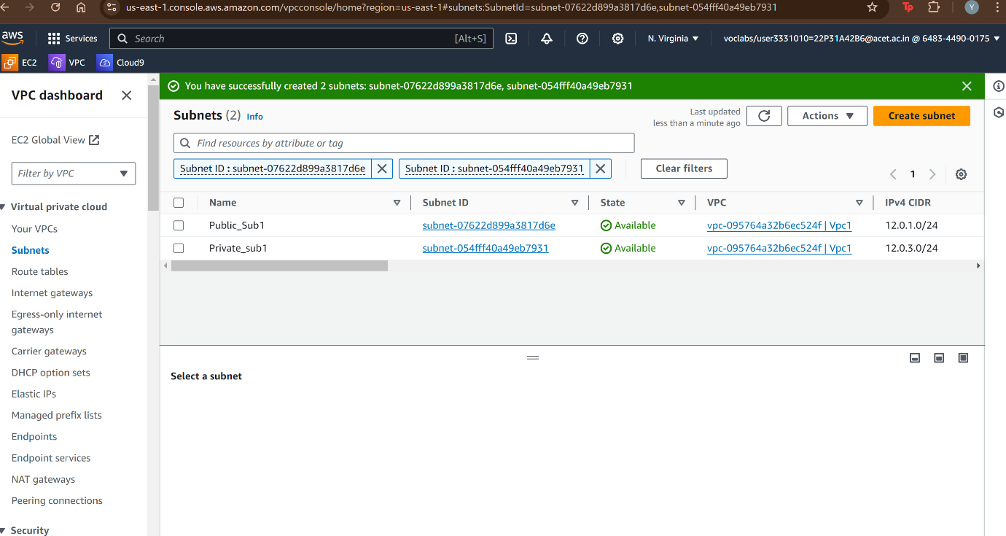

STEP-5: Create a Route table for public subnet.

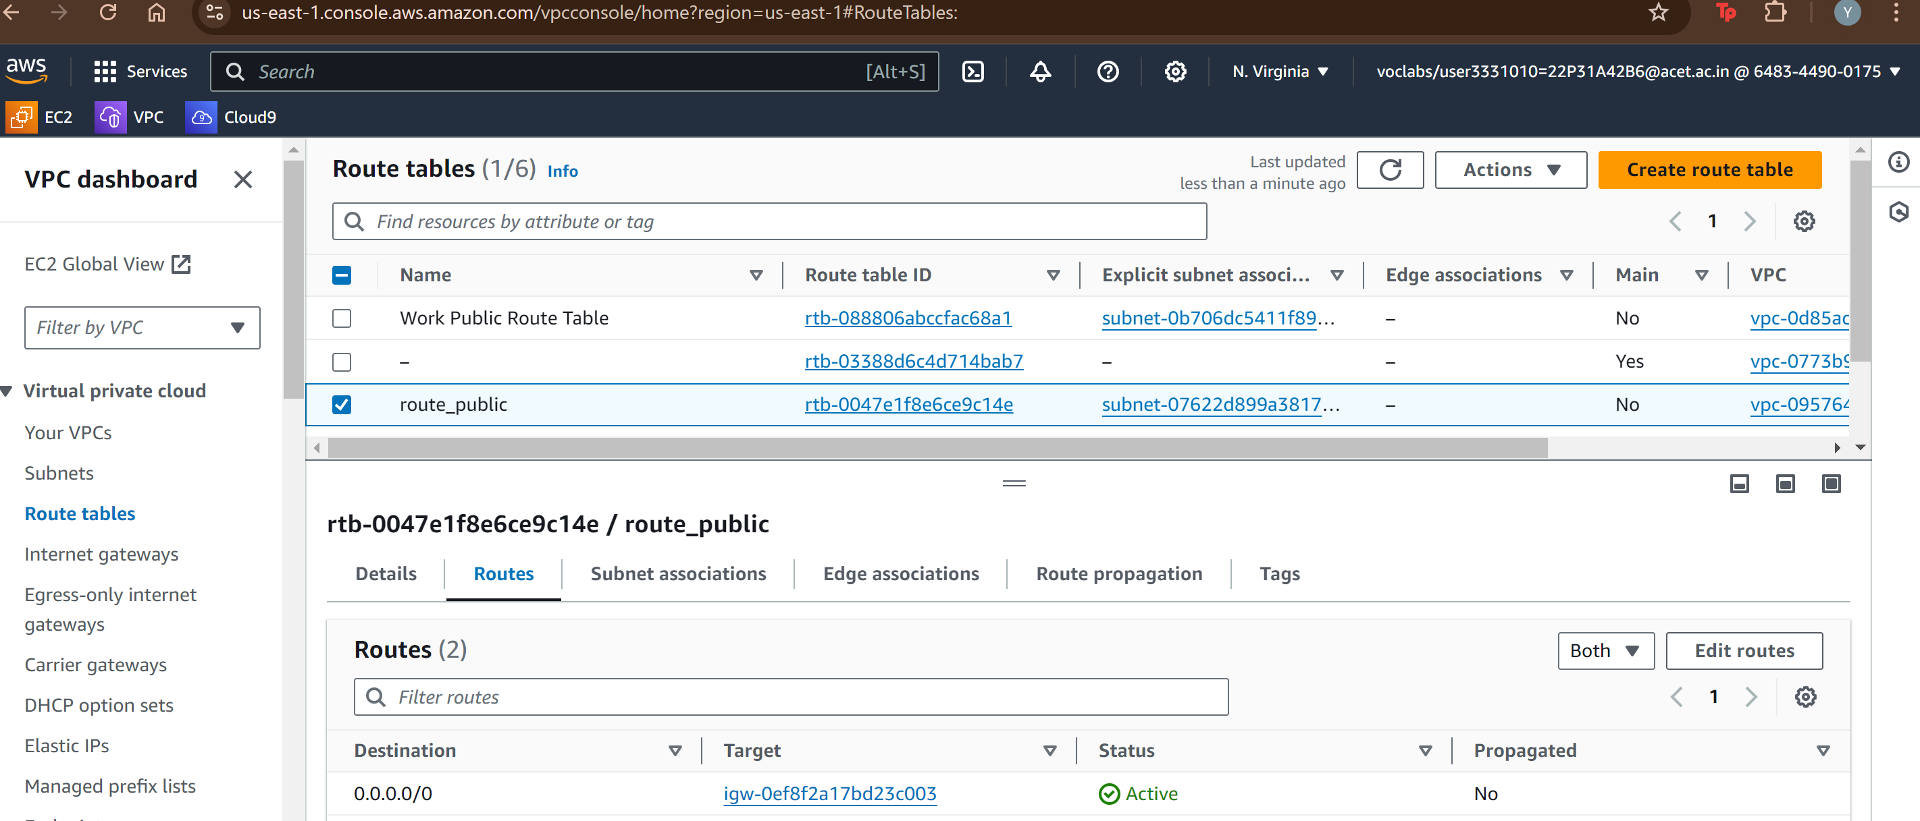

STEP-6: Connecting the public subnet to public route table.

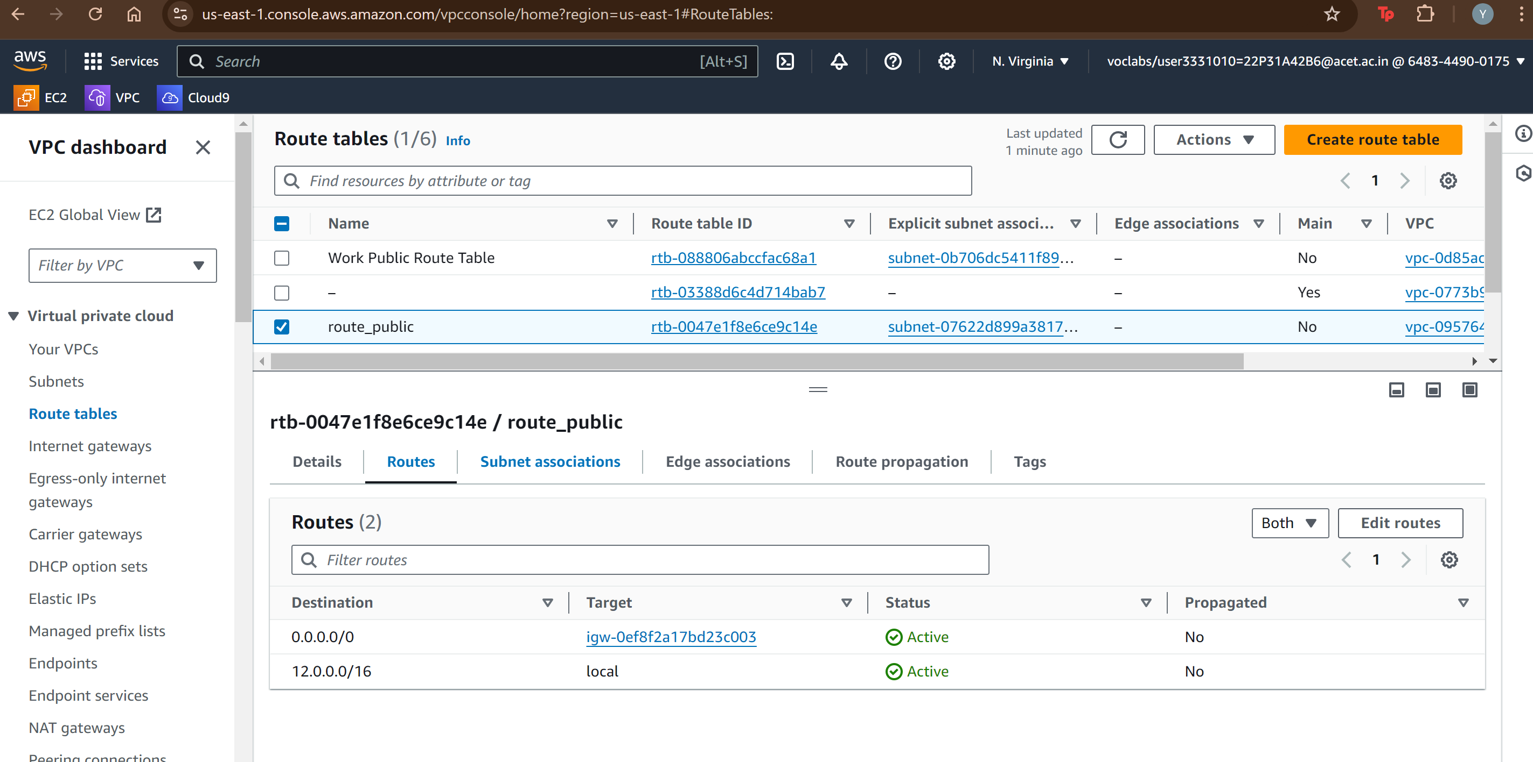

STEP-7: Now creating route table for Private Subnet.

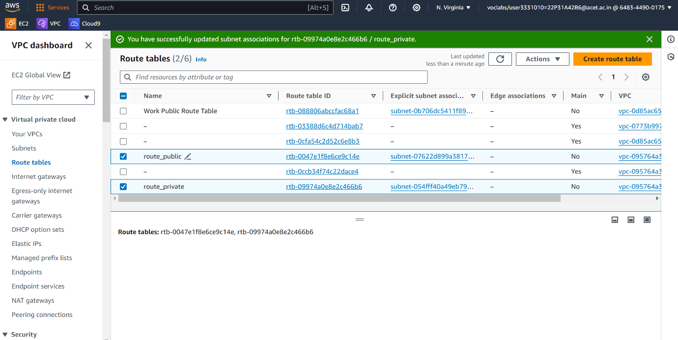

STEP-8: Launching an EC2 instance

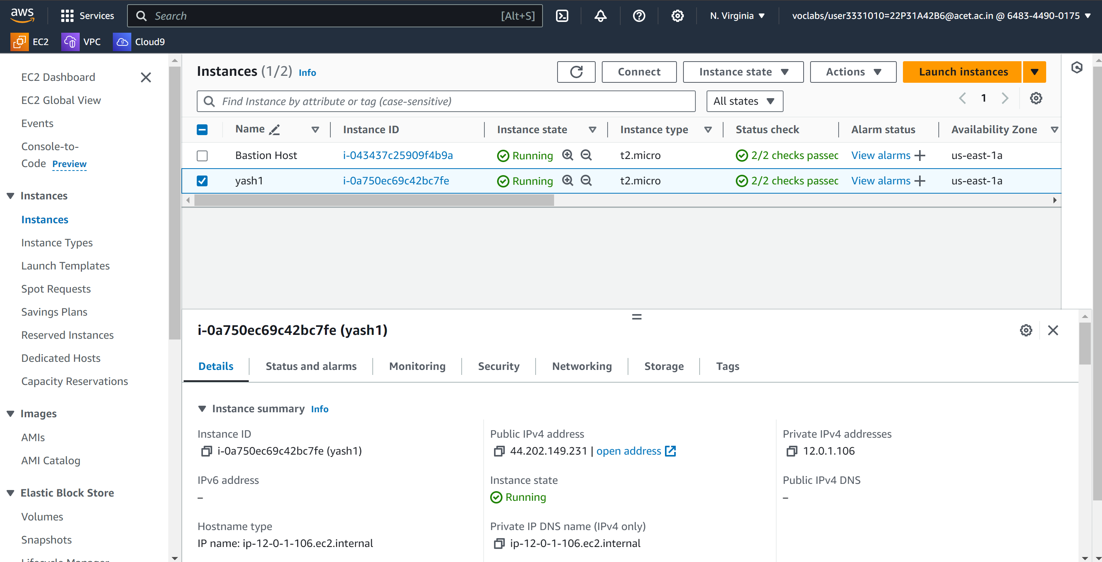

STEP-9: Connecting with Internet

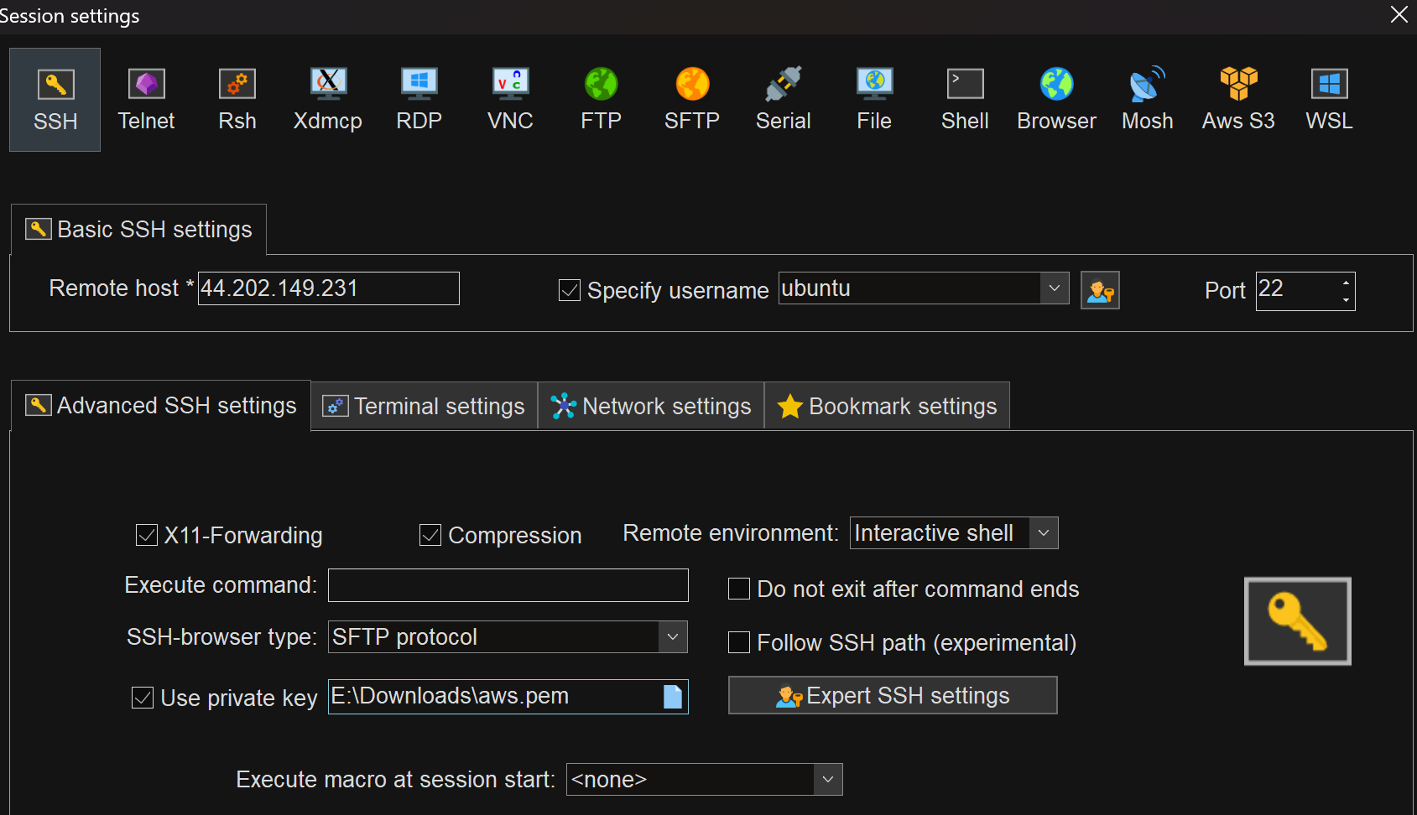

STEP-10: Successful! Secure connection was implemented

